Questions:
- How to choose the right Activation function for NN models?
- What is a neural network without an activation function?
- What is bias?

Explain the advantage of Artificial Neural Network?

Explain the feed-forward neural network?

How does the learning rate affect the training of the Neural Network?

Why is ReLU the most commonly used Activation Function?

Explain the vanishing and exploding gradient problems.

What do you mean by Optimizers?

Overfitting is one of the most common problems every Machine Learning practitioner faces. Explain some methods to avoid overfitting in Neural Networks.

Answers:

- An activation function in a neural network defines how the weighted sum of the input is transformed into an output from a node or nodes in a layer of the network.
The choice of activation function in the hidden layer will control how well the network model learns the training dataset. The choice of activation function in the output layer will define the type of predictions the model can make. We need some logic / heuristics to know which activation function should be used in which situation. Good or bad – there is no rule of thumb. However, depending upon the properties of the problem we might be able to make a better choice for easy and quicker convergence of the network.
- Sigmoid functions and their combinations generally work better in the case of classifiers
- Sigmoids and tanh functions are sometimes avoided due to the vanishing gradient problem
- ReLU function is a general activation function and is used in most cases these days
- If we encounter a case of dead neurons in our networks the leaky ReLU function is the best choice
- Always keep in mind that ReLU function should only be used in the hidden layers
- As a rule of thumb, you can begin with using ReLU function and then move over to other activation functions in case ReLU doesn’t provide with optimum results.
- In case of neural network without the activation functions, every neuron will only be performing a linear transformation on the inputs using the weights and biases. Although linear transformations make the neural network simpler, but this network would be less powerful and will not be able to learn the complex patterns from the data.
A neural network without an activation function is essentially just a linear regression model. Thus, we use a non-linear transformation to the inputs of the neuron and this non-linearity in the network is introduced by an activation function.

- We predict the output (y) based on a given input (x) in the neural network. We can create a model, i.e. (mx + c), which help the user to predict the result. When we train any model, it gets the appropriate value of the constants m and c.
This constant c is bias. Bias helps a model in such a way that it can fit best for given data. We can say bias gives freedom to act best.

4. There are various advantages of an artificial neural network which are given below:
a. In traditional programming, data or information is stored in a database, but the data is stored in the whole network in the neural network.
b. The artificial neural network can work with incomplete knowledge. After providing the training data set to the model, it may produce output even without the complete information.
c. It is capable of parallel processing. The ANN has numerical strength which can perform more than one task at the same time.
d. The ANN has the potential for high tolerance. When the artificial neural networks are scaled across multiple machines and multiple servers. So, the neural network can route around the missing data or server and nodes that can't communicate.
e. The artificial neural network can learn from the examples and apply them when a similar event or task arises and make them work through the real-time event.

  - The feed-forward neural network is an artificial neural network in which the nodes are not connected in the form of cycle. The feed-forward neural network is completely different from the recurrent network. This is the first and simplest type of artificial neural network. The data or input travels in one direction in this network. It may or may not have the hidden layers. The feed-forward neural networks are responsive to noisy data and easy to maintain. The information or data flow in this network is left to right.
It is also known as the multi-layered network of neurons. The feed-forward neural network consists of the number of simple neuron-like processing units and organized in layers. Each unit in a layer is connected with all the units in the previous layer.
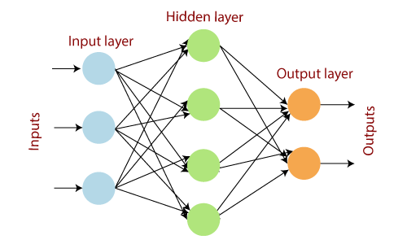

  - While selecting the learning rate to train the neural network, we have to choose the value very carefully due to the following reasons:
If the learning rate is set too low, training of the model will continue very slowly as we are making very small changes to the weights since our step size that is governed by the equation of gradient descent is small. It will take many iterations before reaching the point of minimum loss.
If the learning rate is set too high, this causes undesirable divergent behavior to the loss function due to large changes in weights due to a larger value of step size. It may fail to converge (the model can give a good output) or even diverge (data is too chaotic for the network to train).
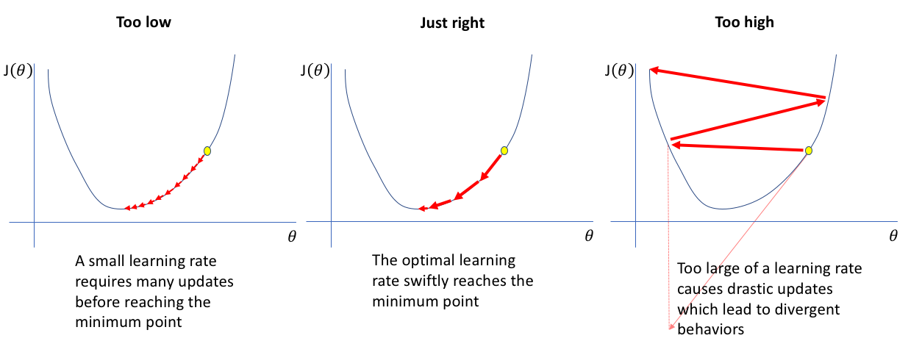

  - ReLU (Rectified Linear Unit) is the most commonly used activation function in neural networks due to the following reasons:
1. No vanishing gradient: The derivative of the RELU activation function is either 0 or 1, so it could be not in the range of [0,1]. As a result, the product of several derivatives would also be either 0 or 1, because of this property, the vanishing gradient problem doesn’t occur during backpropagation.
2. Faster training: Networks with RELU tend to show better convergence performance. Therefore, we have a much lower run time.
3. Sparsity: For all negative inputs, a RELU generates an output of 0. This means that fewer neurons of the network are firing. So, we have sparse and efficient activations in the neural network.

  - These are the major problems in training deep neural networks.
- While Backpropagation, in a network of n hidden layers, n derivatives will be multiplied together. If the derivatives are large e.g, If use ReLU like activation function then the value of the gradient will increase exponentially as we propagate down the model until they eventually explode, and this is what we call the problem of Exploding gradient.
- On the contrary, if the derivatives are small e.g, If use a Sigmoid activation function then the gradient will decrease exponentially as we propagate through the model until it eventually vanishes, and this is the Vanishing gradient problem.

9. Optimizers are algorithms or methods that are used to adjust the parameters of the neural network such as weights, biases, and learning rate, etc to minimize the loss function. These are used to solve the optimization problems by minimizing the function.
The most common used optimizers in deep learning are as follows:
- Gradient Descent
- Stochastic Gradient Descent (SGD)
- Mini Batch Stochastic Gradient Descent (MB-SGD)
- SGD with momentum
- Nesterov Accelerated Gradient (NAG)
- Adaptive Gradient (AdaGrad)
- AdaDelta
- RMSprop
- Adam

10. Dropout: It is a regularization technique that prevents the neural network from overfitting. It randomly drops neurons from the neural network during training which is equivalent to training different neural networks. The different networks will overfit differently, so the net effect of the dropout regularization technique will be to reduce overfitting so that our model will be good for predictive analysis.
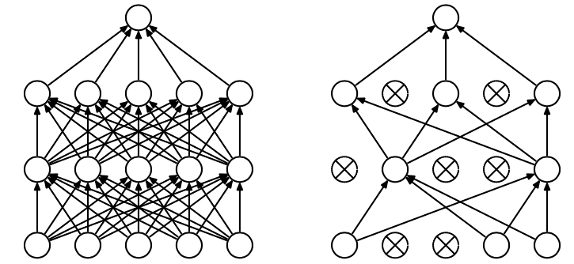

Early stopping: This regularization technique updates the model to make it better fit the training data with each iteration. After a certain number of iterations, new iterations improve the model. After that point, however, the model begins to overfit the training data. Early stopping refers to stopping the training process before that point.
